

Recruitment Workflow Management System
Requirement and Design Specification

Document ID: REP-02
Version: 1.0-RC1
Date: 2026-07-15
Group: SE20A05 Group 7
Related documents: Report index · Traceability · SDS · Screen URLs

Record of changes
Version | Date | Type | Owner | Description
0.1 | 2026-05-28 | Added | Group 7 | RMS workflow pivot and four-actor target model
0.9 | 2026-07-06 | Modified | Group 7 | Unified HR role and requirement v1.0 completion rules
1.0-RC1 | 2026-07-15 | Modified | Group 7 | Replaced template content with code-backed requirements, mappings and diagrams

Contents
1. Overview
1.1 Purpose
1.2 Scope
1.3 Actors
1.4 Use-case model
2. Overall functionality
2.1 End-to-end workflow
2.2 Screen flow and placeholders
2.3 Screen authorization
2.4 Non-UI functions
3. High-level design
3.1 Architecture
3.2 Database design
4. Functional requirements
4.1 Identity and organization - FR-01
4.2 Recruitment requests - FR-02 and FR-03
4.3 Campaign planning - FR-04 through FR-07
4.4 Job posting, candidate and CV - FR-08 through FR-11
4.5 Interviews - FR-12, FR-13 and FR-16
4.6 Interview result, decision and offer - FR-14, FR-15, FR-17 and FR-18
4.7 Notifications and reminders - FR-19
4.8 Tracking and reports - FR-20 through FR-22
5. Business rules
6. Non-functional requirements
7. Assumptions, dependencies and limitations
Assumptions
Dependencies
Limitations
8. Acceptance and traceability

1. Overview

1.1 Purpose
RMS is an internal enterprise hiring platform that governs recruitment from a department's staffing need through HR review, Admin approval, campaign planning, candidate/CV operations, panel interviews, final decision, offer response and reporting.
The central business argument is that recruitment activity is not free-form: approval and a valid campaign plan unlock downstream operations, every transition is traceable, and human actors retain all hiring authority.

1.2 Scope
In scope:
- Account/session, organization, department and role management.
- Recruitment request review and multi-stage approval.
- Overall campaign plan and dated task assignments.
- Job posting, candidate profile, CV upload, parse, embedding and search.
- Interview panel selection, conflict checks, invitations, attendance and feedback.
- Admin hiring decision, offer/rejection communication and candidate response.
- Realtime tracking, annual reports, department statistics and notifications.
Out of scope for 1.0-RC1:
- Payroll, onboarding, employee performance and HRIS integration.
- Autonomous AI ranking or hiring decisions.
- Multi-database-per-service deployment.
- Production SLA, disaster recovery certification and audited compliance controls.

1.3 Actors
Actor | Implemented role | Responsibilities | Data scope
Admin / Boss | ADMIN | User/org governance, request/plan approval, final hiring decision, reports | Organization-wide
Department Head | DEPARTMENT_HEAD | Create staffing request, revise/track it, join interview panel | Own department and owned requests
HR Leader | HR_LEADER | Review requests, plan campaign, manage tasks/posting/CV/interviews/offers | HR-managed workflow
Candidate | CANDIDATE | Maintain profile/CV, view interviews/notifications, answer offers | Own profile, schedules and offers
System / Worker | Service identity | CV processing, embeddings, email, reminders, audit and health | Task-scoped internal access

Older planning documents that say HR_MANAGER or HR_RECRUITER are interpreted as HR_LEADER for this release.

1.4 Use-case model
Editable diagram: system-use-cases.puml
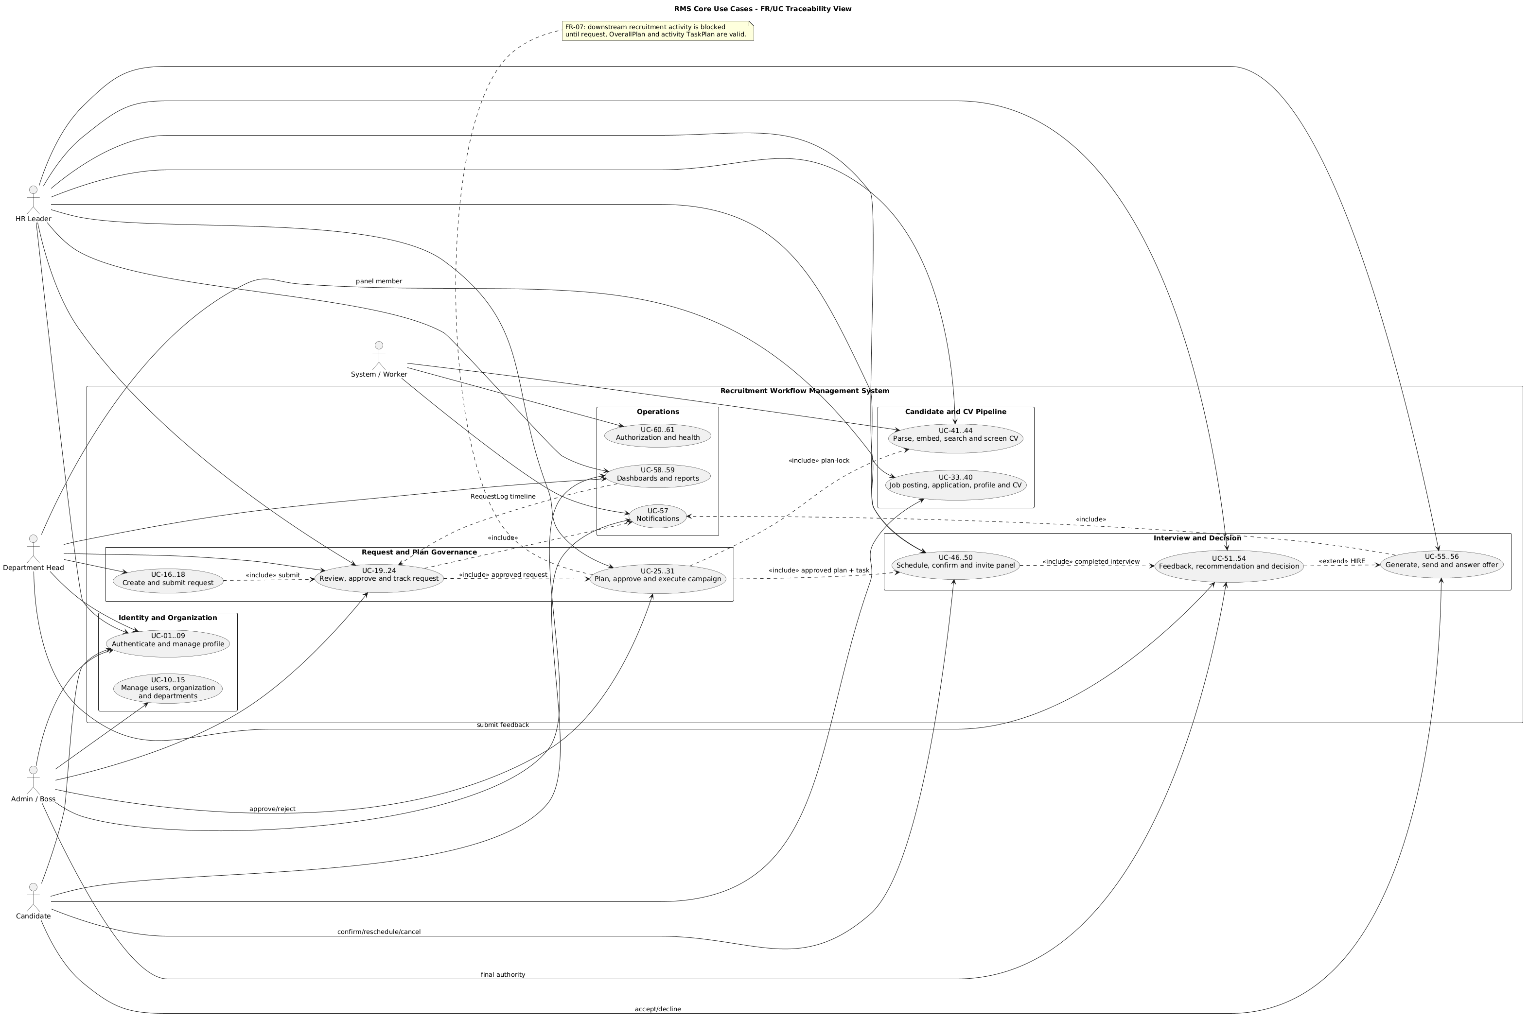
Figure: System Use Cases — editable PlantUML source linked above
The canonical detailed catalog contains 61 use cases in docs/use-case-specifications.md. This specification groups them without changing their IDs:
Range | Capability | Primary actors
UC-01..UC-09 | Authentication, own profile and calendar integration | All users
UC-10..UC-15 | Users, roles, organizations, departments and team members | Admin, Department Head
UC-16..UC-24 | Recruitment request creation, review, approval and tracking | Department Head, HR, Admin
UC-25..UC-31 | OverallPlan, TaskPlan and campaign execution | HR, Admin
UC-32..UC-45 | Job posting, application, candidate profile, CV and search | HR, Admin, Candidate, Worker
UC-46..UC-56 | Interview, feedback, final decision and offer | HR, Department Head, Admin, Candidate
UC-57..UC-61 | Notifications, dashboards, reports, security and health | All actors, System

2. Overall functionality

2.1 End-to-end workflow
Editable state diagram: recruitment-state-machine.puml
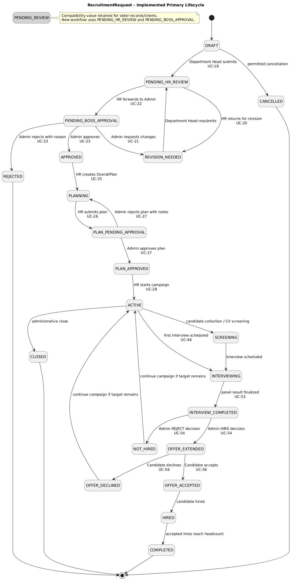
Figure: Recruitment State Machine — editable PlantUML source linked above
Primary path:
TEXT
DRAFT -> PENDING_HR_REVIEW -> PENDING_BOSS_APPROVAL -> APPROVED
-> PLANNING -> PLAN_PENDING_APPROVAL -> PLAN_APPROVED -> ACTIVE
-> SCREENING / INTERVIEWING -> INTERVIEW_COMPLETED
-> OFFER_EXTENDED or NOT_HIRED
-> OFFER_ACCEPTED / OFFER_DECLINED -> HIRED -> COMPLETED

Revision, rejection, close and cancellation branches are shown in the PUML source. Compatibility values in the enum are not all valid next states from every point; service methods enforce transitions.

2.2 Screen flow and placeholders
- Role-based editable screen flow: docs/screen-flow.puml.
- Complete route placeholder registry: screens.md.
- All examples use http://localhost:3000 as the web host placeholder.
Actor | Entry URL | Core route set
Admin | http://localhost:3000/admin | approval queue, requests, interview results, users, settings, reports
Department Head | http://localhost:3000/dept-head | create/track request, interviews, feedback, settings
HR Leader | http://localhost:3000/hr | requests, campaigns, tasks, postings, candidates, interviews, reports
Candidate | http://localhost:3000/candidate | profile, CV, notifications, interviews and offers

2.3 Screen authorization
Capability | Admin | Department Head | HR Leader | Candidate
Manage users/org/departments | Full | Department settings only | Read as required | No
Create request | No | Own department | No | No
Review/forward request | Decision/revision | Revise own | Review/forward | No
Approve plan | Yes | View status | Create/submit/start | No
Manage candidate/CV search | Review | Read when panel/department scoped | Operational | Own profile/CV only
Schedule interview | Review/cancel where allowed | Panel view/feedback | Yes | Respond to own schedule
Final decision | Yes | No | Recommend | No
Offer | Review/decision path | No | Generate/send path | Own offer response
Reports | Organization-wide | Own department | Pipeline/workload | No

Frontend route guards improve navigation, but the Gateway JWT/role guards and service ownership/state checks are the authorization boundary.

2.4 Non-UI functions
ID | Function | Trigger | Result
NF-01 | CV text extraction | Candidate CV upload/replace | Raw text and processing state stored
NF-02 | Structured CV extraction | Worker job; optional configured extractor | Structured profile/CV JSON stored
NF-03 | Embedding generation | Successful parse | Chunked 384-dimension vectors stored in pgvector
NF-04 | Email delivery | Interview, decision, offer, reminder events | EmailLog plus queued delivery/retry
NF-05 | Task reminders | 24 hours before deadline and at deadline | Unique TaskReminder and notification/email
NF-06 | Realtime notifications | Domain events | Notification plus SSE delivery bridge
NF-07 | Audit trail | Status-changing actions | RequestLog and/or generic AuditLog
NF-08 | Aggregated health | GET /api/v1/health | Gateway and service health response

3. High-level design

3.1 Architecture
Editable architecture diagram: package-architecture.puml
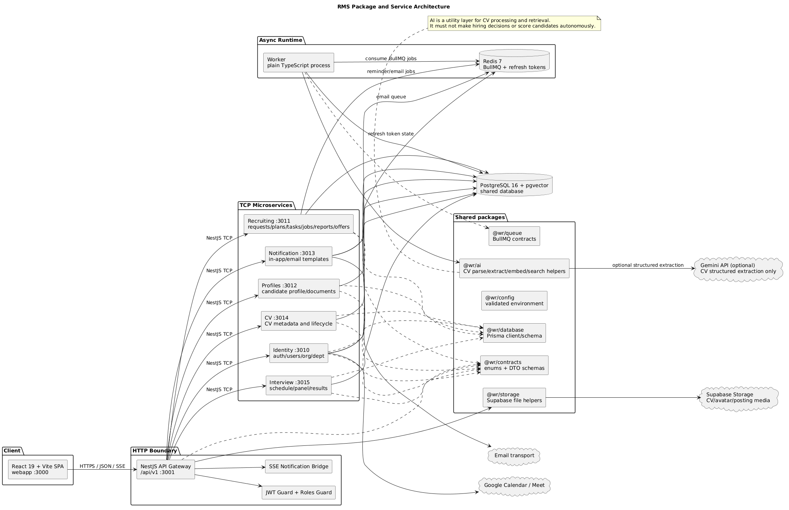
Figure: Package Architecture — editable PlantUML source linked above
TEXT
React SPA -> API Gateway /api/v1 -> NestJS TCP microservices
-> shared PostgreSQL + pgvector
-> Redis/BullMQ workers
-> storage, calendar and email providers

All frontend HTTP calls go through the Gateway. Internal services use message patterns and do not expose public HTTP routes. Shared contracts are the intended source of enum/DTO truth.

3.2 Database design
Editable entity/class diagram: domain-class-diagram.puml
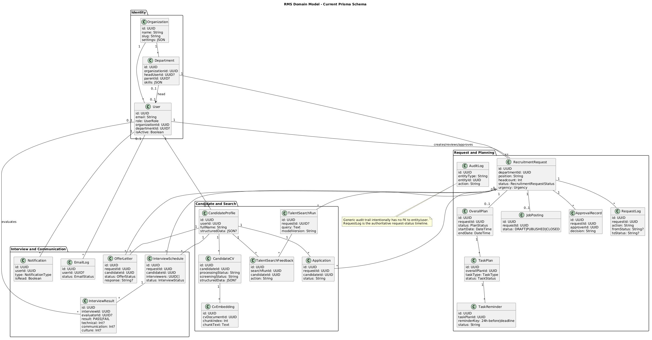
Figure: Domain Class Diagram — editable PlantUML source linked above
The current schema contains 22 Prisma models grouped as follows:
Domain | Models
Identity | User, Organization, Department
Request governance | RecruitmentRequest, JobPosting, ApprovalRecord, RequestLog, AuditLog
Planning | OverallPlan, TaskPlan, TaskReminder
Candidate/search | CandidateProfile, CandidateCV, CvEmbedding, Application, TalentSearchRun, TalentSearchFeedback
Interview/communication | InterviewSchedule, InterviewResult, OfferLetter, Notification, EmailLog

Detailed fields and access design are in REP-03 §3.

4. Functional requirements

4.1 Identity and organization - FR-01
Field | Specification
Use cases | UC-01..UC-15, UC-60
Actors | Admin, Department Head, HR Leader, Candidate
Preconditions | Organization exists for users; role and active state are valid
Normal flow | Register/verify/login; Admin manages users/org/departments; user updates own profile
Exceptions | Duplicate email/slug/code; invalid OTP/token; inactive user; forbidden role/scope
Postconditions | User/session/org structure is persisted; protected routes expose only permitted data
Screens | SCR-COM-01..06, SCR-ADM-05..06, SCR-DH-05
APIs | /api/v1/auth/*, /users, /organizations, /departments, /me/profile

4.2 Recruitment requests - FR-02 and FR-03
Field | Specification
Use cases | UC-16..UC-24
Trigger | Department Head identifies a staffing need
Required input | Position, headcount, job description, skills, justification and urgency
Normal flow | Draft -> submit -> HR review -> Admin decision -> approved/rejected/revision
Alternative flows | HR returns for revision; Admin requests changes; Admin rejects with reason
Exceptions | Not owner; invalid status; missing request; invalid assignee; blank rejection/revision reason
Postconditions | Request, approval record and transition log reflect the same decision; stakeholders are notified
Screens | SCR-DH-02..03, SCR-HR-02, SCR-ADM-02..03
APIs | /recruitment-requests, /:id/submit, /assign, /return-for-revision, /forward-to-admin, /request-changes, /decision

Detailed sequence: sequence-request-approval.puml.
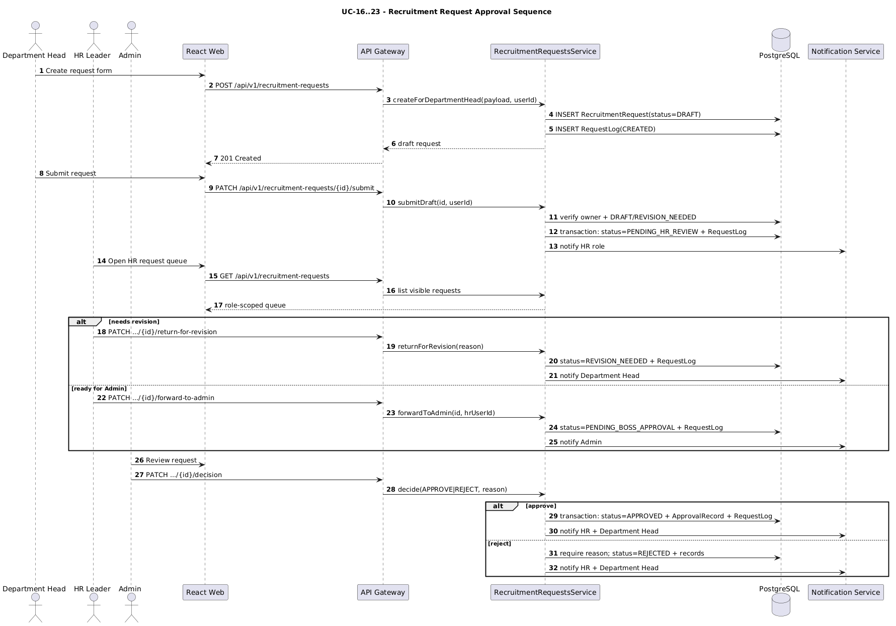
Figure: Sequence Request Approval — editable PlantUML source linked above

4.3 Campaign planning - FR-04 through FR-07
Field | Specification
Use cases | UC-25..UC-31
Preconditions | Request is approved; HR Leader is authorized
Normal flow | Create OverallPlan -> add dated TaskPlans -> submit -> Admin approve -> start campaign
Task types | JOB_POSTING, CV_COLLECTION, CV_SCREENING, INTERVIEW_COORDINATION, HIRING
Validation | Plan dates ordered; task dates fall within plan; active HR assignee; required task coverage
Exceptions | Plan not editable/approved; missing assignee/deadline; invalid task status; revision required
Postconditions | Approved plan and tasks unlock only their permitted recruitment activities
Screens | SCR-HR-03..06, SCR-ADM-02
APIs | /overall-plan, /overall-plan/:id/*, /task-plan, /task-plan/:id/*

Plan-lock business rule:
- Request status must permit the requested operation.
- An OverallPlan must exist and be APPROVED.
- The required activity TaskPlan must exist and be assigned appropriately.
- Services reject the action with a specific failure reason when any condition fails.

4.4 Job posting, candidate and CV - FR-08 through FR-11
Field | Specification
Use cases | UC-32..UC-45
Actors | Candidate, HR Leader, Admin, Department Head (read scope), Worker
Normal flow | Candidate manages profile/CV; worker parses/embeds; HR searches/screens; posting is published under approved campaign
File constraints | PDF, DOCX and DOC are accepted by current Gateway CV flow; maximum 10 MiB
Search rule | Vector/hybrid output supports retrieval; a human makes screening and hiring decisions
Exceptions | Unsupported file, storage failure, parse failure, missing embedding, forbidden candidate, plan-lock failure
Postconditions | Current CV/profile/search feedback are persisted and traceable
Screens | SCR-CAN-02..03, SCR-HR-06..08
APIs | /candidate-profiles, /candidate/cvs, /cv/search, /talent/search, /job-postings

4.5 Interviews - FR-12, FR-13 and FR-16
Field | Specification
Use cases | UC-46..UC-50
Preconditions | Approved plan; INTERVIEW_COORDINATION task; candidate application exists
Input | Candidate, request, ISO-8601 start time, 15-480 minute duration, location, panel IDs
Panel rule | At least two distinct active internal users; scheduler may be included in resolved panel
Normal flow | Validate plan/panel -> check conflicts -> transactionally create schedule/update states/log -> notify candidate/panel
Alternative flows | Candidate confirms/requests reschedule/cancels; HR reschedules/cancels with reason
Exceptions | Past/invalid time, conflict, insufficient/invalid panel, missing application, unauthorized ownership
Postconditions | Schedule and status/logs agree; invitations and delivery logs are available
Screens | SCR-HR-09..10, SCR-DH-04, SCR-CAN-05
APIs | /interviews/schedules, /interviews/requests/:requestId/schedules, confirm/reschedule/cancel/invitations

Detailed sequence: sequence-plan-and-interview.puml.
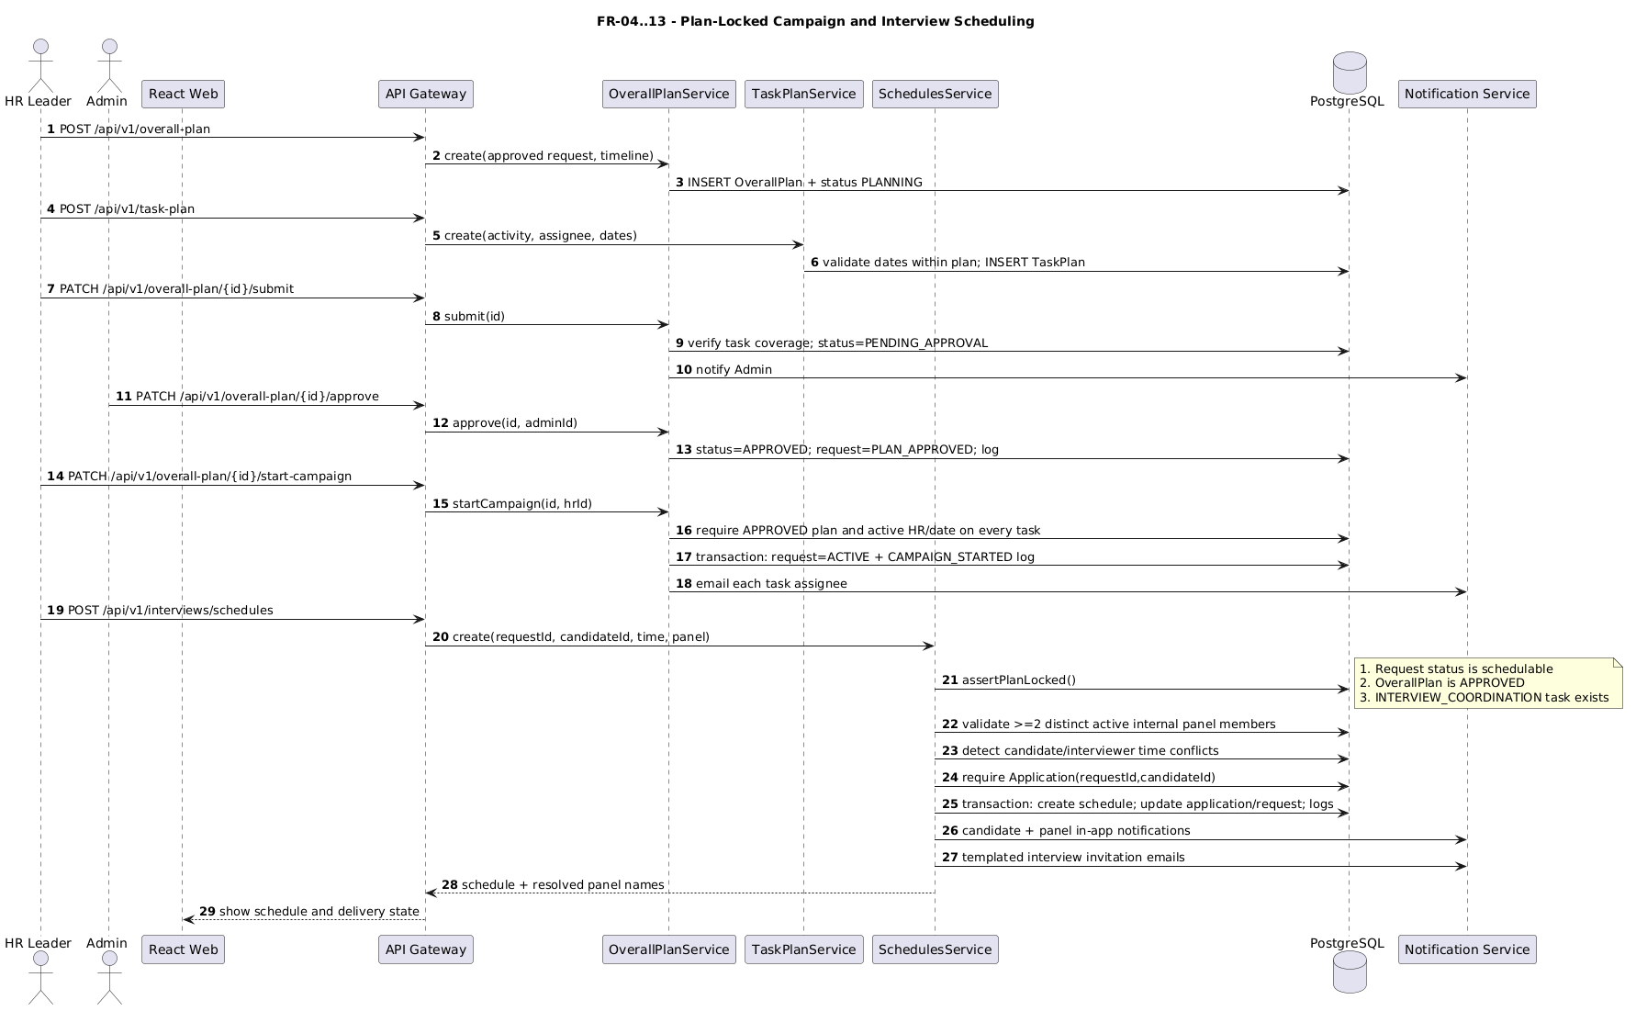
Figure: Sequence Plan And Interview — editable PlantUML source linked above

4.6 Interview result, decision and offer - FR-14, FR-15, FR-17 and FR-18
Field | Specification
Use cases | UC-51..UC-56
Feedback | Invited/authorized panel member records PASS/FAIL, technical, communication, culture and notes
Recommendation | HR Leader submits final recommendation/summary for Admin review
Decision | Admin selects HIRE or REJECT; HIRE requires candidate, compensation and valid start date
Communication | Decision transaction creates request/application/log/notification/email state before queueing delivery
Offer response | Candidate owner may answer only a SENT offer once with ACCEPT or DECLINE and optional note
Completion | Accepted hires reaching headcount close job posting, complete hiring task/plan and request
Exceptions | Not panel/owner, absent PASS evidence, offer not SENT, duplicate response, invalid compensation/date
Screens | SCR-HR-11, SCR-ADM-04, SCR-CAN-06..07
APIs | /hr-interview-results, /admin-interview-results, /hiring-decisions, /offers

Detailed sequence: sequence-hiring-offer.puml.
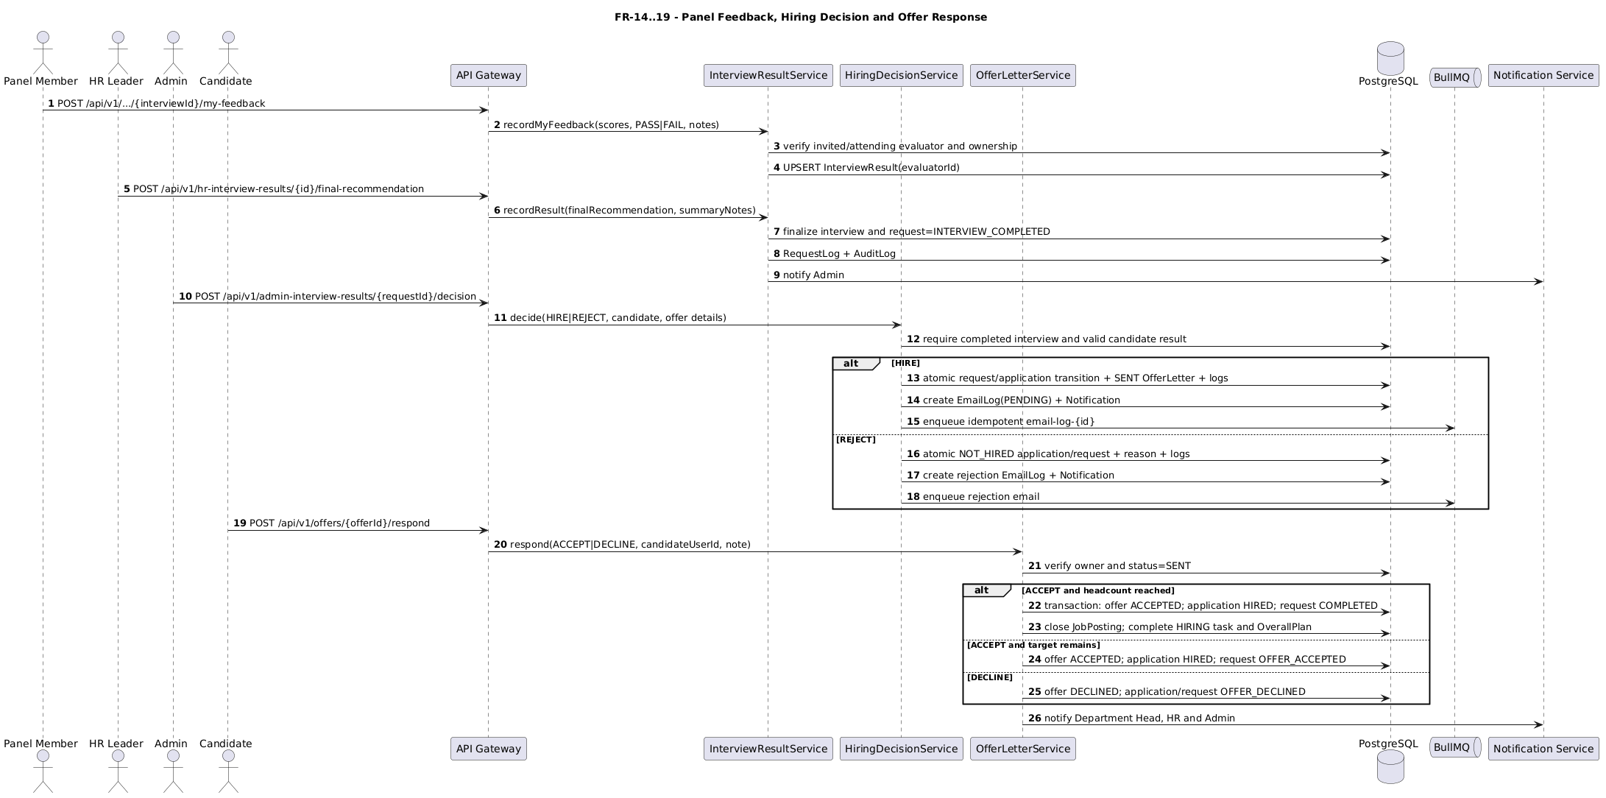
Figure: Sequence Hiring Offer — editable PlantUML source linked above

4.7 Notifications and reminders - FR-19
Field | Specification
Use cases | UC-49, UC-57
Channels | Stored in-app notification, SSE delivery and email queue
Reminder windows | 24h-before and deadline
Eligibility | Incomplete task, approved plan, active request and valid deadline
Idempotency | Unique (taskPlanId, reminderKey) record; email job IDs derive from persistent log IDs
Exceptions | Queue/provider failure records status/error for retry; completed tasks are skipped
Screens | Notification bell, SCR-HR-13, SCR-CAN-04

4.8 Tracking and reports - FR-20 through FR-22
Field | Specification
Use cases | UC-24, UC-58, UC-59
Realtime output | Status, current owner, pending action, headcount/hired count, task/interview/offer progress, latest log, update time
Scope | Admin all; HR managed; Department Head own department/requests
Reports | Pipeline, time-to-hire, annual export, department stats/report, Admin/HR dashboards
Source | Current workflow tables with RequestLog as request timeline authority
Exceptions | Invalid date range, department outside scope, missing report permissions
Screens | SCR-ADM-01/03/07/08, SCR-DH-01, SCR-HR-01/12

5. Business rules
ID | Rule
BR-01 | Current production-facing roles are exactly ADMIN, DEPARTMENT_HEAD, HR_LEADER, and CANDIDATE.
BR-02 | A Department Head may create/submit only requests in their permitted department scope.
BR-03 | Request rejection/revision requires an attributable reason or response where the action requires it.
BR-04 | Every request status transition creates a RequestLog in the same transaction when feasible.
BR-05 | Recruitment work is blocked until request approval, plan approval and the applicable task assignment are satisfied.
BR-06 | Task dates must fit the OverallPlan and campaign start requires active HR assignees plus dates.
BR-07 | Candidate search/AI output is advisory retrieval data; humans decide shortlist, interview and hire.
BR-08 | CV file operations must enforce type/size/ownership and clean up uploaded storage if database persistence fails.
BR-09 | Interview start must be in the future and duration must be between 15 and 480 minutes.
BR-10 | Interview panel contains at least two distinct active internal users with permitted roles.
BR-11 | Interview scheduling requires an application for the candidate/request pair.
BR-12 | Panel feedback is attributable to the current evaluator and restricted by invitation/role/attendance rules.
BR-13 | Admin is the final hiring authority; HR supplies operational recommendation and may manage explicit offer workflows.
BR-14 | HIRE requires a selected eligible candidate plus compensation and start date.
BR-15 | Only the owner candidate may respond to an offer, and only while it is SENT.
BR-16 | Offer response is immutable after the first valid response.
BR-17 | Campaign completes only when accepted hires meet headcount; otherwise recruitment may continue.
BR-18 | Task reminders are unique by task and reminder window and skip completed/ineligible tasks.
BR-19 | Candidate and organization data is returned only within role/ownership scope.
BR-20 | The Gateway is the public HTTP boundary; internal TCP services are not called directly by the SPA.

6. Non-functional requirements
ID | Requirement | Acceptance for RC1
NFR-01 Security | JWT, role guard, ownership/state validation, safe password/token handling | Implemented with CORS/Helmet/throttling; deployed-policy verification pending
NFR-02 Reliability | Atomic state changes, retryable email jobs, persistent logs | Critical transactions and worker guards present; retry/concurrency run pending
NFR-03 Traceability | RequestLog/AuditLog and document mapping | Implemented and documented
NFR-04 Performance | Pagination, indexed filters, pgvector retrieval, async heavy work | Implemented baseline; load benchmark not release-certified
NFR-05 Maintainability | Strict TypeScript, shared contracts, Gateway boundary, modular services | Implemented baseline
NFR-06 Observability | Health checks, structured logs and correlation IDs | Health, Pino logging and correlation propagation are code-backed; trace exercise pending
NFR-07 Accessibility | Keyboard and color-independent status support | Issue #228 closed; regression review still required per release
NFR-08 Portability | Docker Compose infrastructure and environment validation | Development deployment documented
NFR-09 Testing | Auth, CV and full workflow E2E | Lifecycle script present; full auth and CV-pipeline E2E artifacts incomplete

7. Assumptions, dependencies and limitations

Assumptions
- Organization, departments and internal user accounts are seeded/configured before workflow use.
- Email, storage and calendar provider credentials are supplied by the deployment environment.
- Dates are stored as timestamps; user-facing interview text is displayed for Asia/Ho_Chi_Minh where implemented.
- The official roster and AI session captures are managed outside source control.

Dependencies
- Node.js 22+, npm 10, PostgreSQL 16 with pgvector and Redis 7.
- Supabase storage for managed files in configured environments.
- Google OAuth/Calendar for optional calendar/Meet integration.
- Email transport and optional Gemini configuration for structured CV extraction.

Limitations
- 1.0-RC1 retains compatibility states and some legacy endpoint/document terminology.
- GitHub has zero open issues; REP-04 records closure evidence and residual verification gates.
- Placeholder screen URLs use localhost; deployment URLs are not yet recorded.
- No production claim until deployed security/logging checks, worker retry/concurrency tests, CI/CD and complete auth/CV E2E evidence are verified or risk-accepted.

8. Acceptance and traceability
The normative cross-reference is TRACEABILITY.md. A requirement is document-complete only when its row identifies:
- At least one UC.
- A screen placeholder or explicit non-UI actor.
- A Gateway API/event.
- A concrete controller/service method area.
- Persistent data or an explicit stateless result.
- Design coverage in REP-03.
- Open release risks in REP-04 where applicable.

